GIT and GITHUB

Comparing Git/Github
Below is a table of differences between git and github :
Git is a software | Github is a service
Git is a command-line tool | Github is a graphical user interface
Git is installed locally on system | Github is hosted on website
Git is maintained by Linux | Github is maintained by Microsoft
Git is focused on version control and code sharing | Github is focused on centralize source code hosting
Git was release in 2005 | Github was launched in 2008
Git has no user management feature | Github has a built-in user management feature
Git is open-source licensed | Github includes a free-tier and pay for use tier
Git has minimal external tool configuration | Github has an active marketplace for tool integration
Git provides a Desktop interface named git gui | Github provides a Desktop interface named Github Desktop
Git competes with CVS, Azure DevOps, Server, Subversion | Github competes with Giblab, Git Bucket

Git commands
- git config : This command sets the author name and email address respectively to be used with your commits.​
Usage: git config –global user.name “[name]” ​
Usage: git config –global user.email “[email address]” ​
- git init : This command is used to start a new repository.​
Usage: git init [repository name]​
- git clone : This command is used to obtain a repository from an existing URL.​
Usage: git clone [url]
- git status :This command lists all the files that have to be committed.​
Usage: git status ​
- git add : This command adds a file to the staging area.​
Usage: git add [file] ​
- git commit : This command records or snapshots the file permanently in the version history.​
Usage: git commit -m “[ Type in the commit message]” ​
- git log : This command is used to list the version history for the current branch.​
Usage: git log ​
- git push : This command sends the committed changes of master branch to your remote repository.​
Usage: git push
- git branch : This command lists all the local branches in the current repository.​
Usage: git branch ​
- This command creates a new branch.​
Usage: git branch [branch name] ​
- git checkout : This command is used to switch from one branch to another.​
Usage: git checkout [branch name] ​
- This command creates a new branch and also switches to it.​
Usage: git checkout -b [branch name]
- git merge : This command merges the specified branch’s history into the current branch.​
Usage: git merge [branch name] ​
- git pull : This command fetches and merges changes on the remote server to your working directory.​
Usage: git pull

Demo- Practise Stepbystep

At your local/ your folder in desktop/laptop, you input :
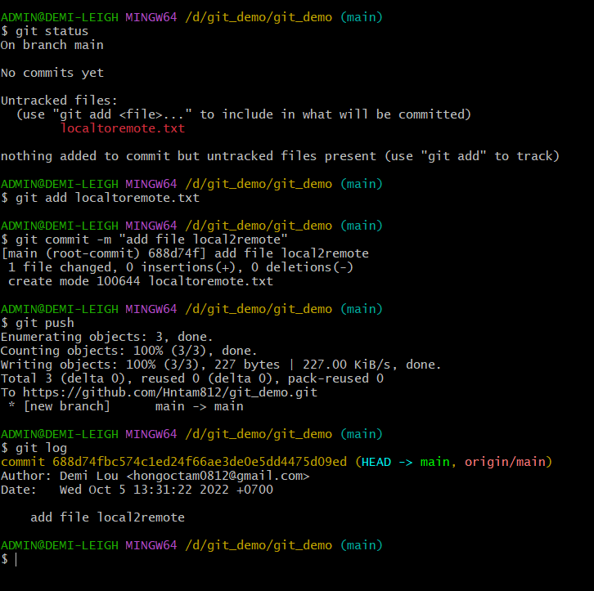
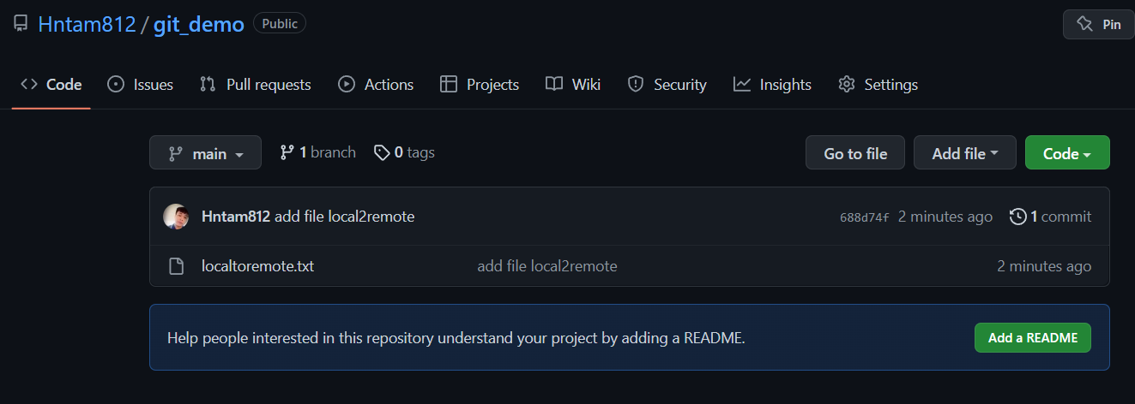

GIT BRANCH CHECKOUT
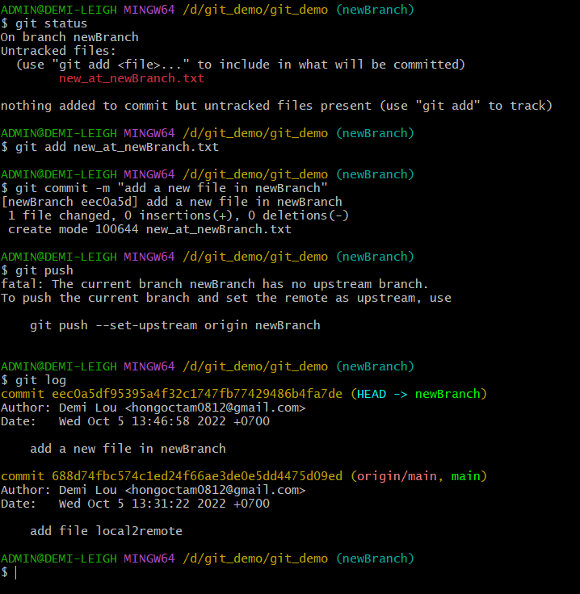

At branch main :
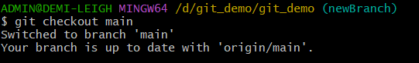
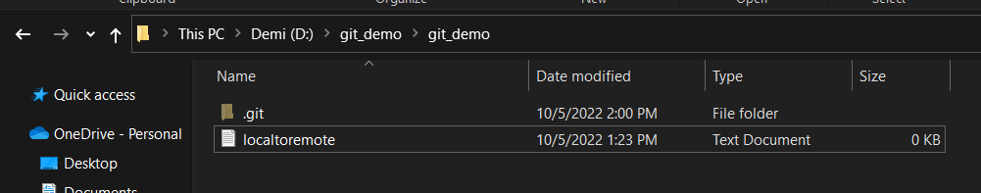

At remote : we check my branch ➔ 2 branch now
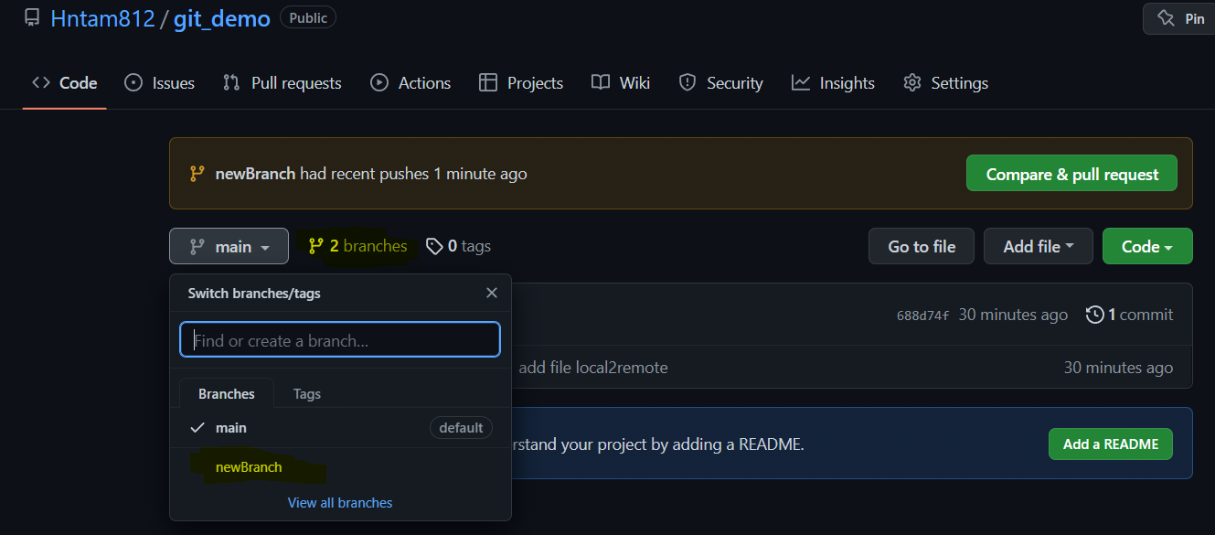
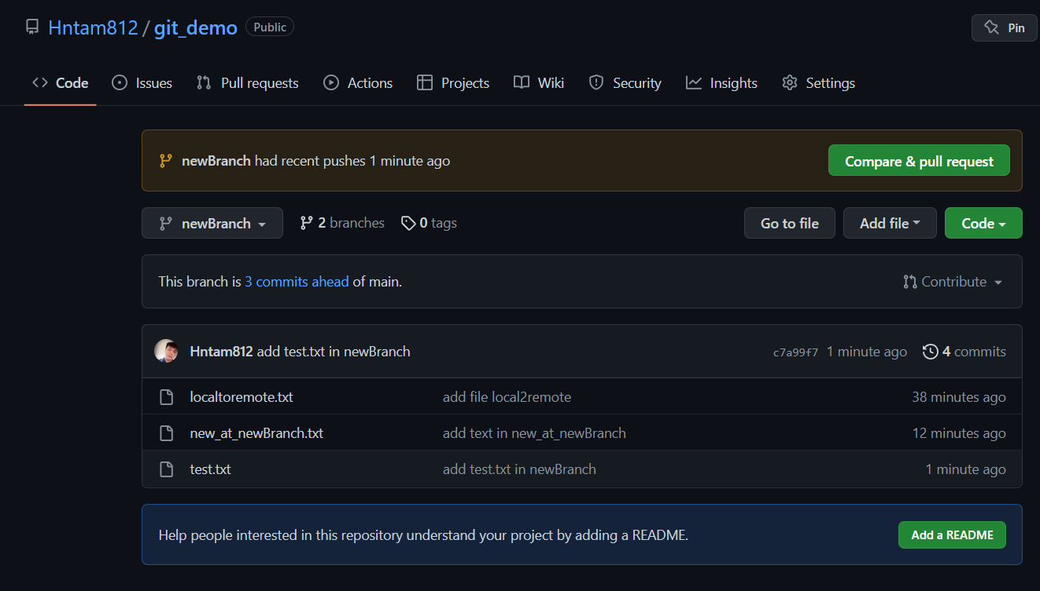
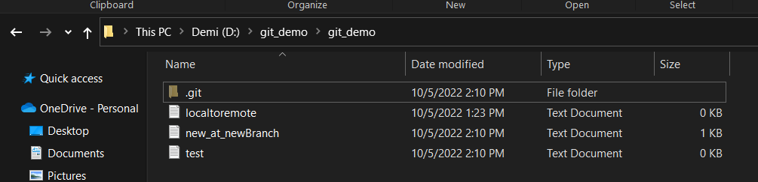

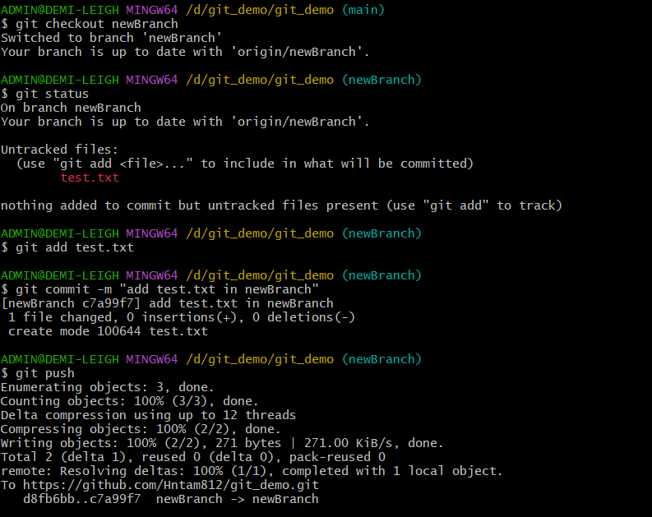

CONFLICT :
